PROJECT TITLE -FONT SIZE TIMES NEW ROMAN 18 WITH LINE SPACING 1.5

COURSE CODE – COURSE NAME
PROJECT REPORT

Submitted by
NAME OF THE STUDENT – UNIQUE ID

In partial fulfilment for the award of the degree of
BACHELOR OF TECHNOLOGY
in
COMPUTER SCIENCE AND ENGINEERING
(Cyber Security & Internet of Things)
Sri Ramachandra Faculty of Engineering and Technology
Sri Ramachandra Institute of Higher Education and Research, Porur, Chennai -600116

MONTH, YEAR

PROJECT TITLE -FONT SIZE TIMES NEW ROMAN 18 WITH LINE SPACING 1.5

COURSE CODE – COURSE NAME
PROJECT REPORT

Submitted by
NAME OF THE STUDENT – UNIQUE ID

In partial fulfilment for the award of the degree of
BACHELOR OF TECHNOLOGY
in
COMPUTER SCIENCE AND ENGINEERING
(Cyber Security & Internet of Things)
Sri Ramachandra Faculty of Engineering and Technology
Sri Ramachandra Institute of Higher Education and Research, Porur, Chennai -600116

MONTH, YEAR

BONAFIDE CERTIFICATE

Certified that this project report “TITLE OF THE PROJECT” is the bonafide record of work done by “NAME OF THE STUDENT – UNIQUE ID” who carried out the internship work under my supervision.

Signature of the Supervisor Signature of Programme Coordinator

Name of Supervisor  Assistant Professor,  Department of Artificial Intelligence and Data Analytics  Sri Ramachandra Faculty of Engineering and Technology,  SRIHER, Porur, Chennai-600 116. | Dr. Jayanthi G  Associate Professor,  Department of Cybersecurity and IoT  Sri Ramachandra Faculty of Engineering and Technology,  SRIHER, Porur, Chennai-600 116.

Evaluation Date:

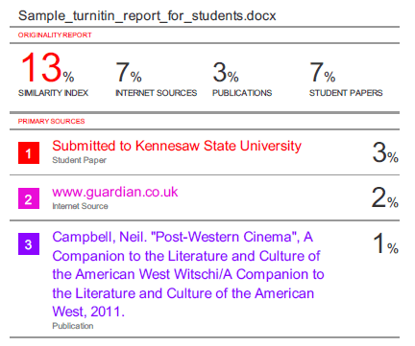
Signature of the Supervisor

ACKNOWLEDGEMENT

I express my sincere gratitude to our Programme Coordinator Dr. Jayanthi G for their support and for providing the required facilities for carrying out this study.
I wish to thank my faculty supervisor(s), NAME OF THE SUPERVISOR, Department of Artificial Intelligence and Machine Learning, Sri Ramachandra faculty of Engineering and Technology and INDUSTRY MENTOR, DESIGNATION -IF APPLICABLE for extending help and encouragement throughout the project. Without his/her continuous guidance and persistent help, this project would not have been a success for me.
I am grateful to all the members of Sri Ramachandra Faculty of Engineering and Technology, my beloved parents and friends for extending the support, who helped us to overcome obstacles in the study.

TABLE OF CONTENTS

CHAPTER NO. | TITLE | PAGE NO.
 | ABSTRACT
 | LIST OF TABLES
 | LIST OF FIGURES
 | LIST OF SYMBOLS
1 | INTRODUCTION | 1
 | - Subheading | 1
 | 1.2 Subheading | 2
 | 1.2.1 Subheading under 1.2 | 3
2 | LITERATURE REVIEW | 5
3 | PROPOSED METHODOLOGY | 13
4 | IMPLEMENTATION | 30
5 | RESULTS AND DISCUSSIONS | 45
 | APPENDICIES | 55
 | Appendix-1: Code – Technical detail | 55
 | Appendix-2: Screenshots | 60
 | REFERENCES | 63
 | WORKLOG | 68
 | CERTIFICATE OF COMPLETION | 75

ABSTRACT

The project completed during the internship at The Sparks Foundation is Gradual Rotational Internship Program done in the field of Data science where a raw dataset is given and we collect the data and data cleansing is done then we prepare the data, build a model for prediction, then test and train the data and finally predict the solution and interpret it. Later use the interpreted solution to visualize the output using visualization tools such as graphs, plots, maps and various other tools.

CHAPTER 1
INTRODUCTION

  - INTRODUCTION TO DATA PREPROCESSING
Data Pre-processing in machine learning is a crucial step that helps enhance the quality of data to promote the extraction of meaningful insights from the data. Real-world data is often incomplete, inconsistent, and/or lacking in certain behaviours or trends, and is likely to contain many errors. Data pre-processing is a proven method of resolving such issues. It converts raw data into understandable and readable data. Data Pre-processing involves three stages - Data Cleaning, Data Transformation, and Data Reduction

  - TECHNIQUES INVOLVED
Once the data is collected, it then enters the data preparation stage. Data preparation, often referred to as “pre-processing” is the stage at which raw data is cleaned up and organized for the following stage of data processing.

1.2.1 Technique 1
Processing is done using machine learning algorithms, though the process itself may vary slightly depending on the source of data being processed and its intended final use.

  - DATA COLLECTION
Collecting data is the first step in data processing. Data is pulled from available sources, including data lakes and data warehouses. It is important that the data sources available are trustworthy and well-built so the data collected is of the highest possible quality.

APPENDICES
APPENDIX-1: CODE COMPILER
tsconfig.spec.json
{
"extends": "./tsconfig.json",
"compilerOptions": {
"outDir": "./out-tsc/spec",
"types": [
"jasmine",
"node"
]
},
"files": [
"src/test.ts",
"src/polyfills.ts"
],
"include": [
"src/**/*.spec.ts",
"src/**/*.d.ts"
]
}

REFERENCES
Journal References:
- Author (Year), “Title of the paper/article”, Title of the Journal or Periodical, volume number (issue number), page numbers.
Web References:
- Python for Data Science - Course for Beginners (Learn Python, Pandas, NumPy, Matplotlib)- https://www.youtube.com/watch?v=LHBE6Q9XlzI

WORKLOG
Day | Date | Task Done
Day 1 | 04/01/2021 | Preparation, cleansing and transformation for number of hours of study-marks scored of students
Day 2 | 05/01/2021 | Training and testing of data
Day 3 | 06/01/2021 | Making predictions and evaluating the model and linear regression task
Day 4 | 07/01/2021 | Prediction using supervised ML
Day 5 | 08/01/2021 | Prediction using supervised ML
Day 6 | 09/01/2021 | Visualization of the data
Day 7 | 11/01/2021 | Prediction using Unsupervised ML
Day 8 | 12/01/2021 | Preparing, training the data
Day 9 | 13/01/2021 | Predicting number of clusters
Day 10 | 18/01/2021 | Prediction using Decision Tree Algorithm
Day 11 | 19/01/2021 | Stock market prediction using textual and numerical analysis
Day 12 | 20/01/2021 | Exploratory Data analysis -Sports-data collection and imports
Day 13 | 21/01/2021 | EDA-Sports- data transformation.
Day 14 | 22/01/2021 | EDA-Sports- predicting profit.
Day 15 | 23/01/2021 | Stock market prediction using textual analysis
Day 16 | 25/01/2021 | Stock market prediction using numerical analysis
Day 17 | 27/01/2021 | EDA-Sports-dashboarding
Day 18 | 29/01/2021 | Eda -sports
Day 19 | 30/01/2021 | Uploading tasks and submission.

OFFER LETTER
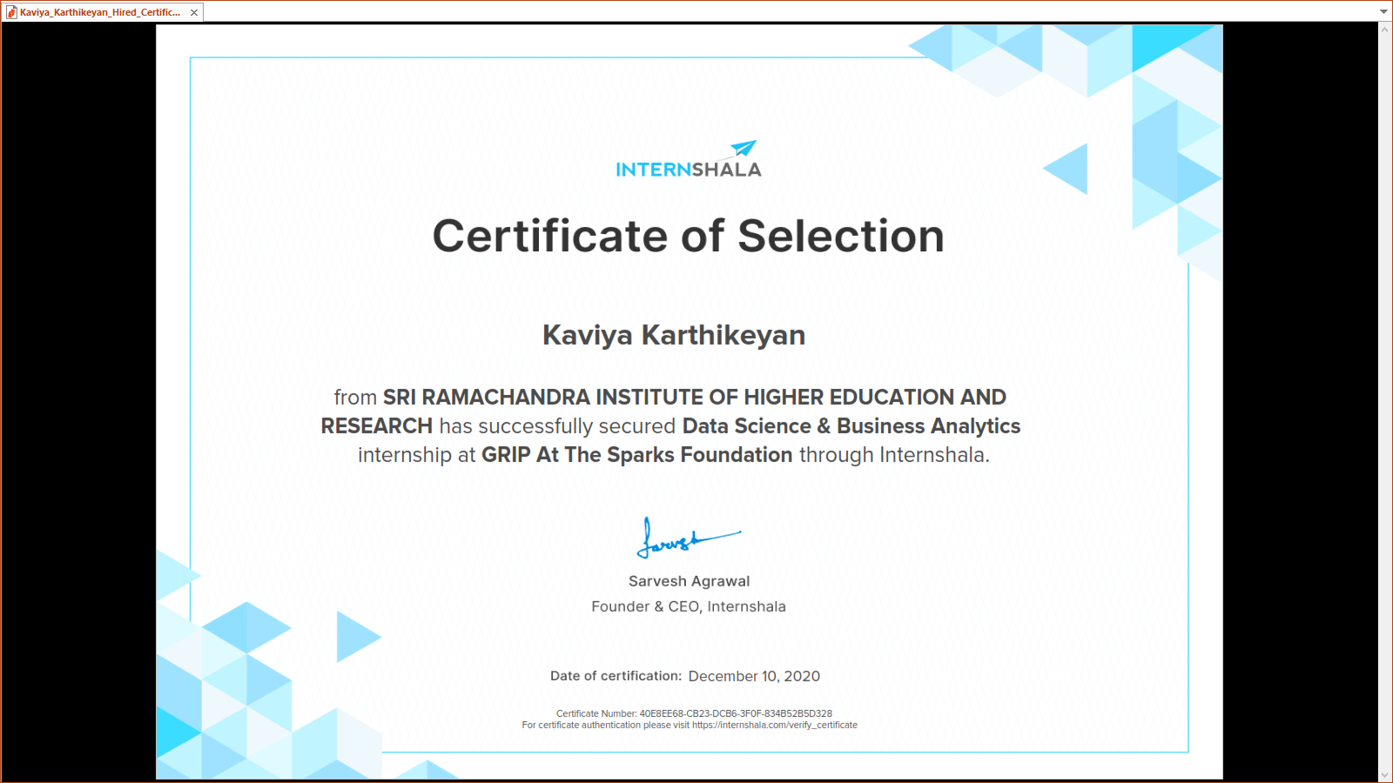

CERTIFICATE OF COMPLETION
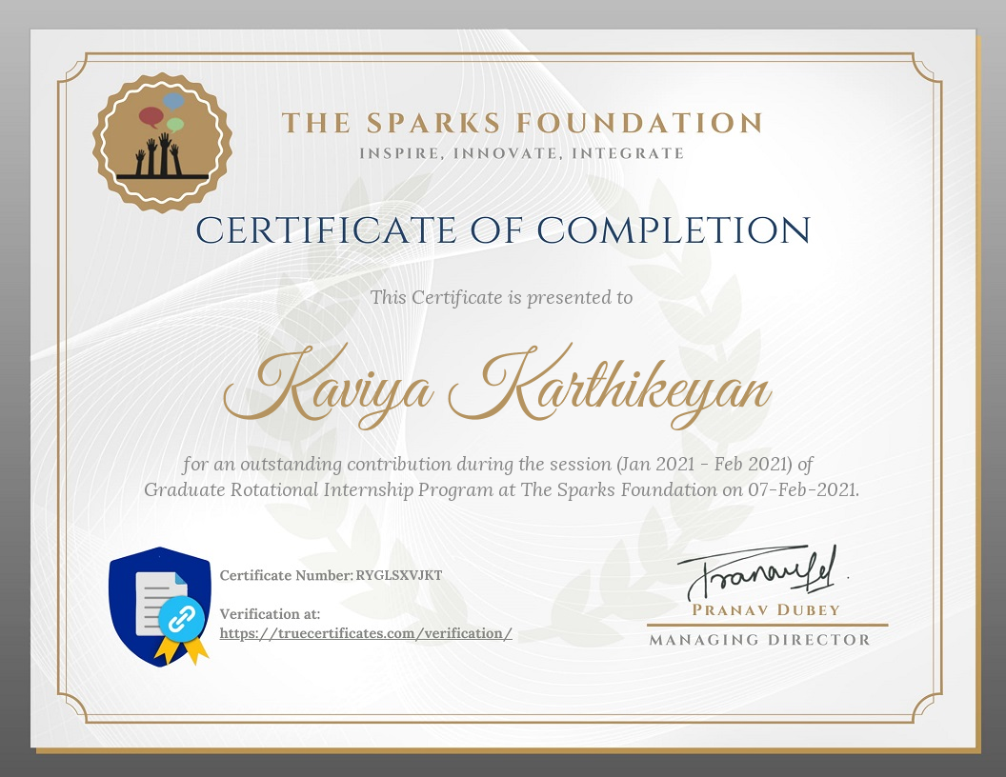

Attendance Form (External)

1. Review 1 Attendance Form
2. Review 2 Attendance Form
3. Final Review Attendance Form

